# Pre and Post Tests Debrief

*This document contains answers and explanations for the manipulative tactics we display in our tests.*

### True Charts

Pair one:

This graph has correctly labeled + well proportionate axes. The plot itself is an accurate representation of the trend of covid cases between Canada and the US. The text of the post correctly interprets the numbers shown in the graph. The statement about the parents is neutral and does not draw any invalid conclusions.

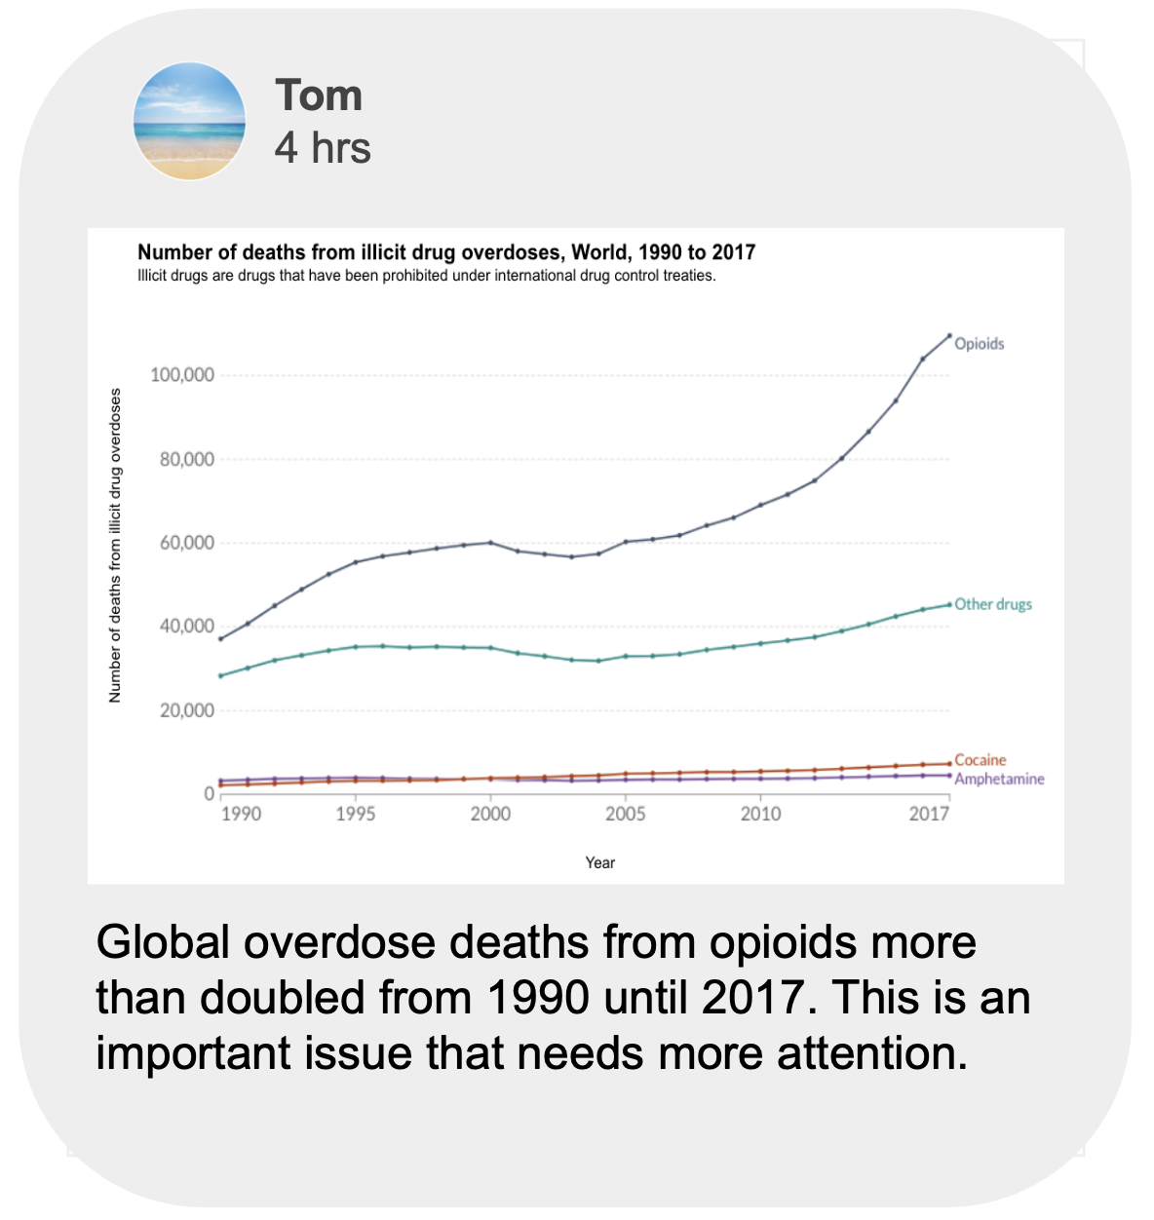

This graph has correctly labeled + well proportionate axes. The plot itself is an accurate representation of overdose deaths from opiods. The text of the post correctly interprets the numbers shown in the graph. The statement about this being an important issue is an opinion that does not exaggerate nor misinterpret any of the facts.

Pair two of true:



The author states a fact about his/her sister’s work and does not try to misuse this information to justify anything. It is stated merely as context. While the claim in this post cannot be verified without additional research, the claim is not stated in a manipulative way.

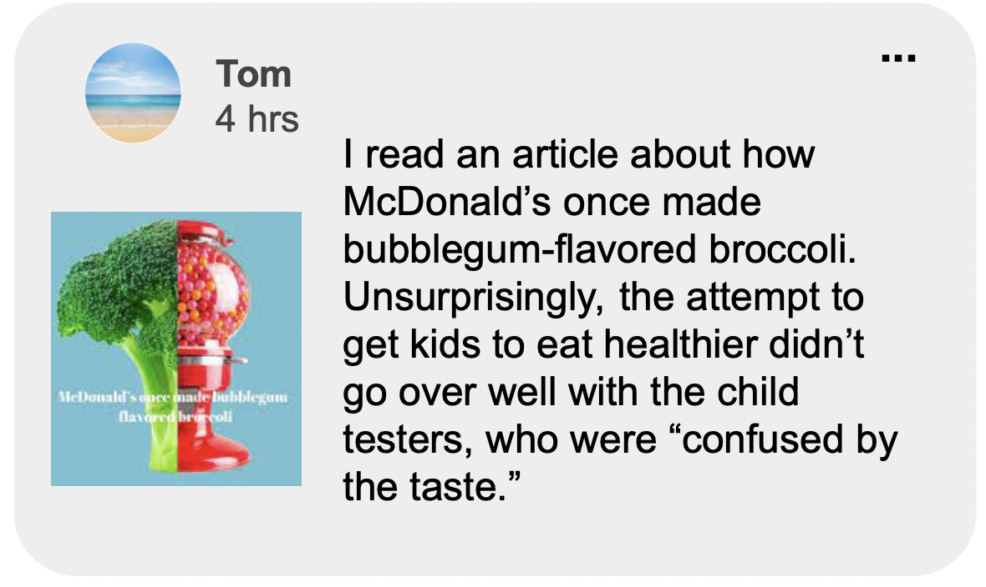

This post describes an article that the author read in a neutral and fact statement manner. It states the conclusions of the article.

### Misleading Graphs

The “No” circle in the diagram is displayed larger than the “Yes” diagram even though the number of “No” responses (1.5 million) is far less than the number of “Yes” responses (8.4 million). The text in the post uses this deceptive proportion to imply that workers do not support unionizing. Notice that the text does not actually say that workers do not support unionizing explicitly and relies on misinterpretation to convey its intention.

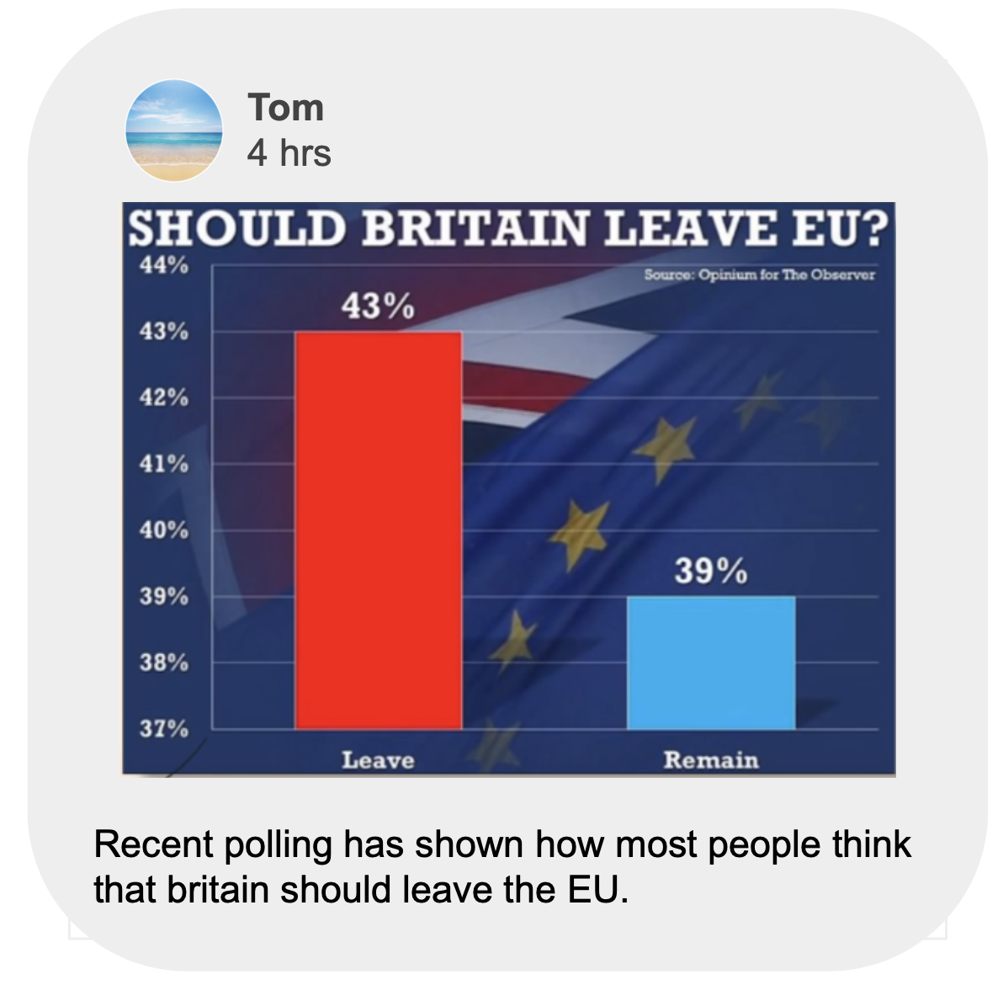

The axis for this graph is changed to start at 37%. This zoomed in version inflates the difference between the 43% and the 39%. This makes it look like the amount of support for leaving the EU is dramatically larger than the amount of support for remaining even though the actual difference is around 4 percentage points.

### False Comparisons



This post falsely compares smoking addiction to video game addiction. Even if the meditation technique does help people overcome their addiction to video games, there is no evidence to suggest that it would help people overcome a smoking addiction which is completely different.



This post states a study that connects students attending schools with music programs to higher standardized testing scores. However, the study did not state that music programs cause students to have higher standardized testing. Furthermore, the Von Gesualdo music program is not comparable to schools with expansive music programs and the reason your child is struggling with grades would likely not be solved from the music program.

### Anecdotes



Even though the author’s grandmother outlived the author’s grandfather, this is just one personal case and may not be applicable to everyone else in the world.

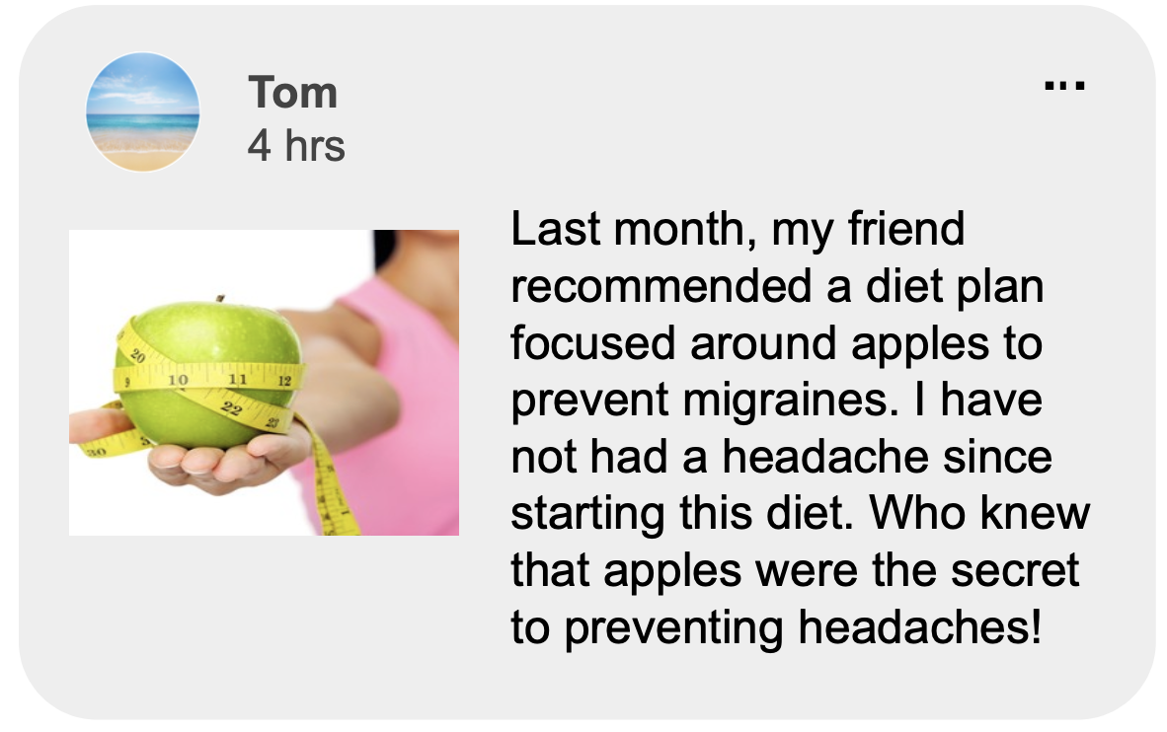

The recommended diet plan that helped the author is a personal anecdote that may not be the solution to preventing headaches for everyone.

### Combined Tactics (graph correct but manipulative post text of anecdote and false comparison)

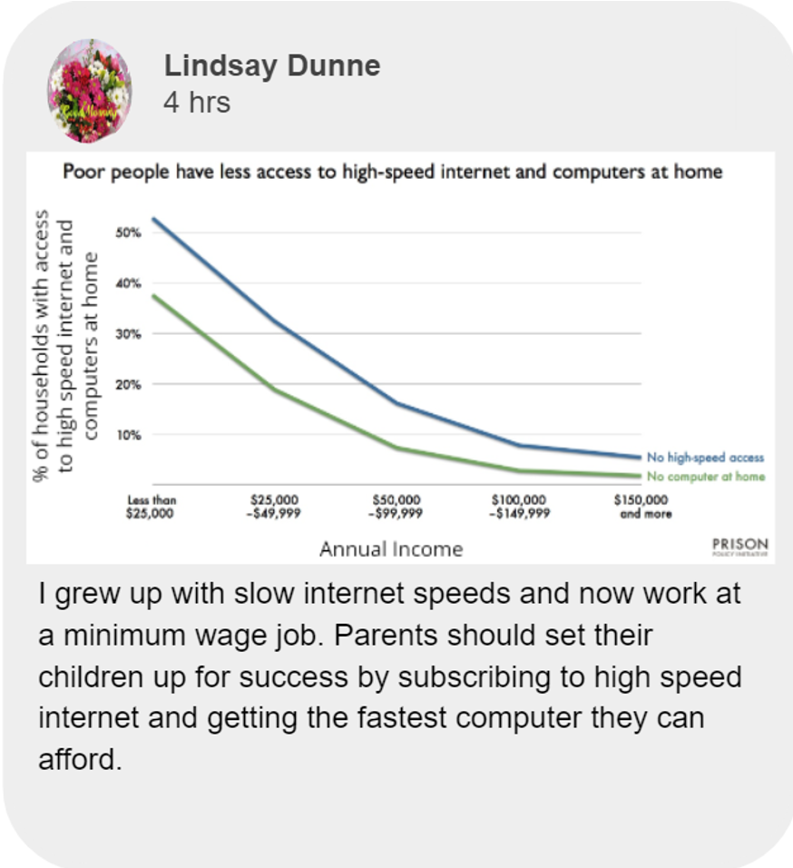

The graph is not misleading since it is well proportioned. It also does show that those with less income have less access to high speed internet and computers.

However, the author uses a personal anecdote that falsely connects this technology access to career success.



The graph is well proportioned and an accurate representation of video game sales. Tetris was indeed one of the best selling video game franchises in 2021.

However, the author then uses an anecdote about his brother and success in concentration to argue that all schools should develop gaming classes. He then falsely compares the gaming to improved test taking performance. This manipulates a best selling data point to support improved test taking performance.